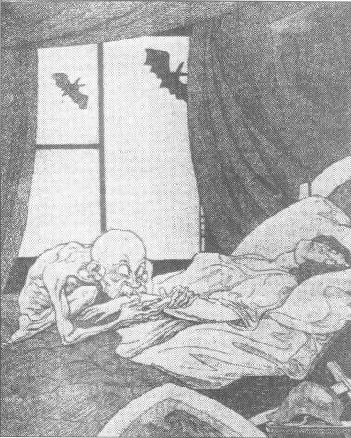
A cartoon from a German newspaper alongside a news story explaining the outcome of the Paris Peace Conference.

- Why is Germany represented as a woman?
- Why is there armour lying at the side of the bed?
- Why is Clemenceau portrayed as a vampire?
- Who are the bats outside the window representing? Why are they no inside the room?
- Why would a German make this cartoon?

